Statistics and Trends: Exploring House Prices
Student Name: Venkata Naga Jayendra Anumula | 25109358 | Data set: House-sales dataset
Introduction
This report examines a dataset of 4,600 house sales, which includes 18 different features such as selling price, number of bedrooms and bathrooms, living space, land size, property condition and location. The main purpose of this analysis is to understand the factors that may influence house prices and identify patterns within the data. It also looks at how house prices are distributed, whether larger living areas are linked to higher selling prices, and how different property features are related to each other. Using statistical methods and visualisations, this report aims to present a clear understanding of the housing market based on the available data.
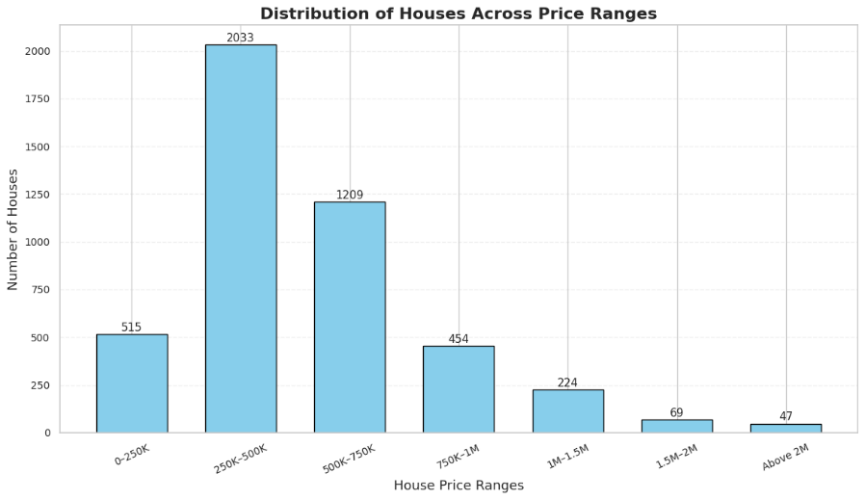
Figure 1: Distribution of houses across price ranges
Analysis of House Price Distribution:
Figure 1 shows how the 4,551 properties with positive sale prices are spread across seven different price ranges. The highest number of properties (2,033) falls within the 250,000–500,000 price range. This is followed by 1,209 properties in the 500,000–750,000 range, while 515 properties are in the lowest price category. As the price ranges increase, the number of properties gradually decreases, with only 47 properties having prices above 2,000,000.
The average house price is 557,905.90, whereas the median price is 465,000.00. This difference suggests that a small number of very expensive properties are increasing the overall average. The skewness value of 25.02 also shows that the distribution is strongly right-skewed, meaning most properties are concentrated in the lower and middle price ranges, while a smaller number of properties have much higher prices.

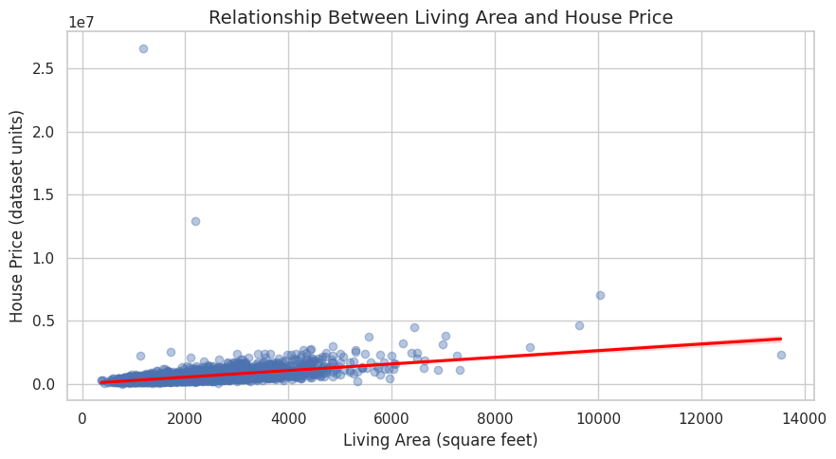
Figure 2: Living area compared with house price
Relationship Between Living Area and House Price:
Figure 2 shows the relationship between the size of a property's living area and its selling price. The results show a correlation value of 0.4455, which indicates a moderate positive relationship between these two variables. In simple terms, houses with larger living areas generally tend to have higher selling prices.
However, the graph also shows that properties with similar living areas can have quite different selling prices. This suggests that other factors, such as location, property condition and views, may also influence the value of a house. Overall, the analysis suggests that living area is an important factor to consider when looking at house prices, but it is not the only factor that determines how much a property sells for.
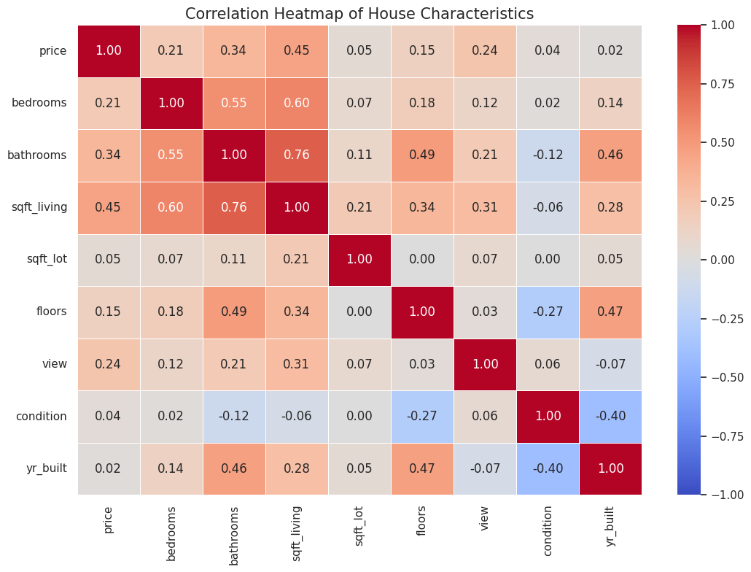
Figure 3: Correlation heatmap of selected numerical variables.
Correlation Between Property Features:
The heatmap shows how nine numerical features in the dataset are related to each other. From the results, the strongest relationship can be seen between the number of bathrooms and the living area (0.76). This means that larger houses generally tend to have more bathrooms. Other noticeable relationships include bedrooms and living area (0.60), and bedrooms and bathrooms (0.55).
When looking specifically at house prices, living area has the highest positive correlation (0.45), followed by the number of bathrooms (0.34) and property view (0.24). These results suggest that the size of a house and the number of bathrooms are more closely related to its selling price than some of the other features included in the analysis.
Overall, the heatmap helps us understand how different property features are connected. However, these relationships do not mean that one feature directly causes a change in another. The results may also be influenced by unusually high or low values in the dataset.
Conclusion
To conclude, this analysis helped to identify some important patterns in the house sales dataset. The results show that house prices vary considerably, with most properties falling within the middle price ranges and only a small number having very high selling prices. The distribution is also strongly right-skewed, which suggests that a few expensive properties increase the overall average price.
The scatter plot shows that houses with larger living areas generally have higher selling prices, although this relationship is not the same for every property. Similarly, the correlation heatmap highlights connections between different features, particularly living area, bedrooms and bathrooms.

